**Name:- Mansi Kapri**

**COURSE:- Bsc(IT) V**

**ROLL NO. : - 1922033**

**UNIVERSITY ID :- 19052006**

**SUBJECT :- MOBILE APPLICATION DEVELOPMENT LAB**

**SUBJECT CODE:- PBI 501**

[Create a program to show implicit intent](http://45.116.207.67/moodle/mod/assign/view.php?id=4823).

<?xml version="1.0" encoding="utf-8"?>

<RelativeLayout xmlns:android[="h](http://schemas.android.com/apk/res/android)tt[p://schemas.android.com/apk/res/android](http://schemas.android.com/apk/res/android)" xmlns:app="[http://schemas.android.com/apk/res-auto"](http://schemas.android.com/apk/res-auto) xmlns:tools="[http://schemas.android.com/tools"](http://schemas.android.com/tools) android:layout_width="match_parent" android:layout_height="match_parent"

tools:context=".MainActivity">

<EditText android:layout_width="match_parent" android:layout_height="wrap_content" android:id="@+id/et_1" android:inputType="text" android:padding="30dp" android:layout_marginTop="30dp"/>

<Button android:layout_width="wrap_content"

android:layout_height="wrap_content"

android:text="Click here"

android:id="@+id/btn_1"

android:textSize="30dp"

android:background="@color/teal_700"

android:layout_below="@+id/et_1"

android:layout_marginLeft="80dp"

android:layout_marginTop="40dp"/>

</RelativeLayout>

**JAVA CODE:-**

package com.example.implicit_intent;

import androidx.appcompat.app.AppCompatActivity; import android.content.Intent;

import android.net.Uri; import android.os.Bundle; import android.view.View; import android.widget.Button;

import android.widget.EditText;

public class MainActivity extends AppCompatActivity { EditText e1;

Buttonbtn;

@Override

protected void onCreate(Bundle savedInstanceState) { super.onCreate(savedInstanceState); setContentView(R.layout.activity_main); e1=findViewById(R.id.et_1); btn=findViewById(R.id.btn_1); btn.setOnClickListener(new View.OnClickListener() {

@Override

public void onClick(View v) { String s=e1.getText().toString();

Intent i=new Intent(Intent.ACTION_VIEW, Uri.parse(s)); startActivity(i);

}

});

}

}

**OUTPUT:-**

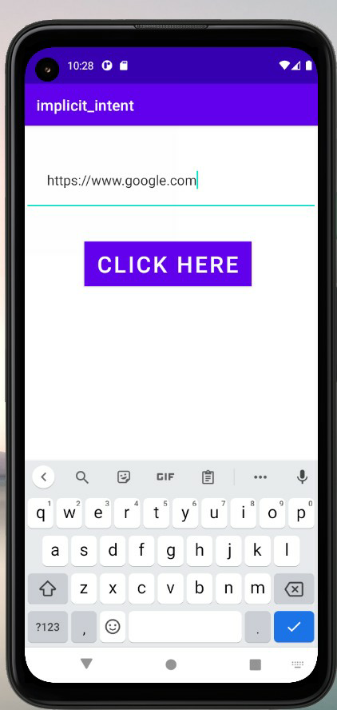

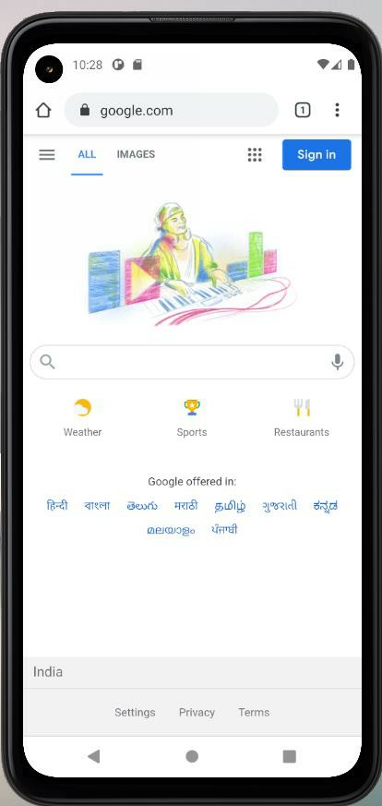

# Create a program to show explicit intent

**MAIN ACTIVITY-1 CODE:**

<?*xml version*="1.0" *encoding*="utf-8"?>

<RelativeLayout *xmlns:android*[="h](http://schemas.android.com/apk/res/android)tt[p://schemas.android.com/apk/res/android](http://schemas.android.com/apk/res/android)" *xmlns:app*[="h](http://schemas.android.com/apk/res-auto)tt[p://schemas.android.com/apk/res-auto"](http://schemas.android.com/apk/res-auto) *xmlns:tools*[="h](http://schemas.android.com/tools)tt[p://schemas.android.com/tools"](http://schemas.android.com/tools) *android:layout_width*="match_parent" *android:layout_height*="match_parent"

*tools:context*=".MainActivity">

<TextView *android:layout_width*="match_parent" *android:layout_height*="wrap_content" *android:text*="Hello, This is Activity1" *android:gravity*="center" *android:layout_marginTop*="90dp" *android:textSize*="40dp" *android:textColor*="@color/teal_200" *android:textStyle*="bold" *android:id*="@+id/tv_1"/>

<Button *android:layout_width*="wrap_content" *android:layout_height*="wrap_content" *android:layout_below*="@+id/tv_1" *android:layout_marginTop*="60dp" *android:id*="@+id/btn1" *android:layout_centerHorizontal*="true" *android:text*="Click Here for Activity2"/>

</RelativeLayout>

**JAVA CODE:**

*package* com.example.explicit_intent;

*import* androidx.appcompat.app.AppCompatActivity;

*import* android.content.Intent;

*import* android.os.Bundle;

*import* android.view.View;

*import* android.widget.Button;

*import* android.widget.TextView;

*public class* MainActivity *extends* AppCompatActivity { TextView tv;

*protected void* onCreate(Bundle savedInstanceState) { *super*.onCreate(savedInstanceState); setContentView(R.layout.*activity_main*);

tv=findViewById(R.id.*tv_1*); btn=findViewById(R.id.*btn1*); btn.setOnClickListener(*new* View.OnClickListener() {

@Override

*public void* onClick(View v) {

*Buttonbtn;*

*@Override*

Intent i=*new* Intent(getApplicationContext(),Activity2.*class*); startActivity(i);

}

});

}

}

# MAIN ACTIVITY-2 CODE:

<?*xml version*="1.0" *encoding*="utf-8"?>

<RelativeLayout>

*xmlns:android*[="h](http://schemas.android.com/apk/res/android)tt[p://schemas.android.com/apk/res/android](http://schemas.android.com/apk/res/android)" *xmlns:app*[="h](http://schemas.android.com/apk/res-auto)tt[p://schemas.android.com/apk/res-auto"](http://schemas.android.com/apk/res-auto) *xmlns:tools*[="h](http://schemas.android.com/tools)tt[p://schemas.android.com/tools"](http://schemas.android.com/tools) *android:layout_width*="match_parent" *android:layout_height*="match_parent"

*tools:context*=".Activity2">

<TextView *android:layout_width*="match_parent" *android:layout_height*="wrap_content" *android:text*="Hello This is Activity2" *android:textSize*="40dp" *android:layout_centerHorizontal*="true" *android:layout_centerVertical*="true" *android:textColor*="@color/teal_200"/>

</RelativeLayout>

**OUTPUT:-**

